Low Level Design

# House Price Prediction

|  |  |
| --- | --- |
| **Written By** | Subhajit Ghosh |
| **Document Version** | 0.1 |
| **Last Revised Date** | 14-08-2023 |

**DOCUMENT CONTROL**

## Change Record:

|  |  |  |  |
| --- | --- | --- | --- |
| **VERSION** | **DATE** | **AUTHOR** | **COMMENTS** |
| 0.1 | 14-08-2023 | Subhajit Ghosh | Introduction and architecture defined |
| 0.1 | 14-08-2023 | Subhajit Ghosh | Architecture & Architecture description appended and updated. |
| 0.1 | 14-08-2023 | Subhajit Ghosh | Architecture |
| 0.1 | 14-08-2023 | Subhajit Ghosh | Architecture Description |
| 0.1 | 14-08-2023 | Subhajit Ghosh | Deployment |

**Reviews:**

|  |  |  |  |
| --- | --- | --- | --- |
| **VERSION** | **DATE** | **REVIEWER** | **COMMENTS** |
|  |  |  |  |

**Approval Status:**

|  |  |  |  |  |  |
| --- | --- | --- | --- | --- | --- |
| **VERSION** | **REVIEW**  **DATE** | **REVIEWED BY** |  | **APPROVED BY** | **COMMENTS** |
|  |  |  |  |  |  |

**Contents**

1. **Introduction 04**
   1. **What is Low-Level Design Document? 04**

|  |  |  |
| --- | --- | --- |
| **1.2** | | **Scope 04** |
| **2.** | **Architecture 05** | |
| **3.** | **Architecture Description 08** | |
|  | **3.1** | **Data Description 08** |
|  | **3.2** | **Web Scrapping 08** |
|  | **3.3** | **Data Transformation 08** |
|  | **3.4** | **Data insertion into database 08** |
|  | **3.5** | **Connection with SQL server 08** |
|  | **3.5** | **Export Data from database 12** |
|  | **3.6** | **Deployment 12** |
| **4.** | **Unit** | **test cases 15** |

1. **Introduction**
   1. **What is Low-Level design document?**

The purpose of the Low-Level Design Document (LLDD) is to outline the intricate logic and internal design of the House Price Prediction dashboard's actual source code. This document details the class diagrams containing methods and relationships among classes, as well as program specifications. It elucidates the various modules, enabling programmers to directly translate the document into program code.

## Scope

Low-Level Design (LLD) signifies a process of designing at the component level, proceeding through a systematic process of refinement. This approach proves invaluable for devising data structures, essential software architecture, source code, and ultimately, performance-driven algorithms. In essence, while the arrangement of data might be initially established during requirement analysis, it attains greater precision and sophistication during the phase of data design.

# Architecture

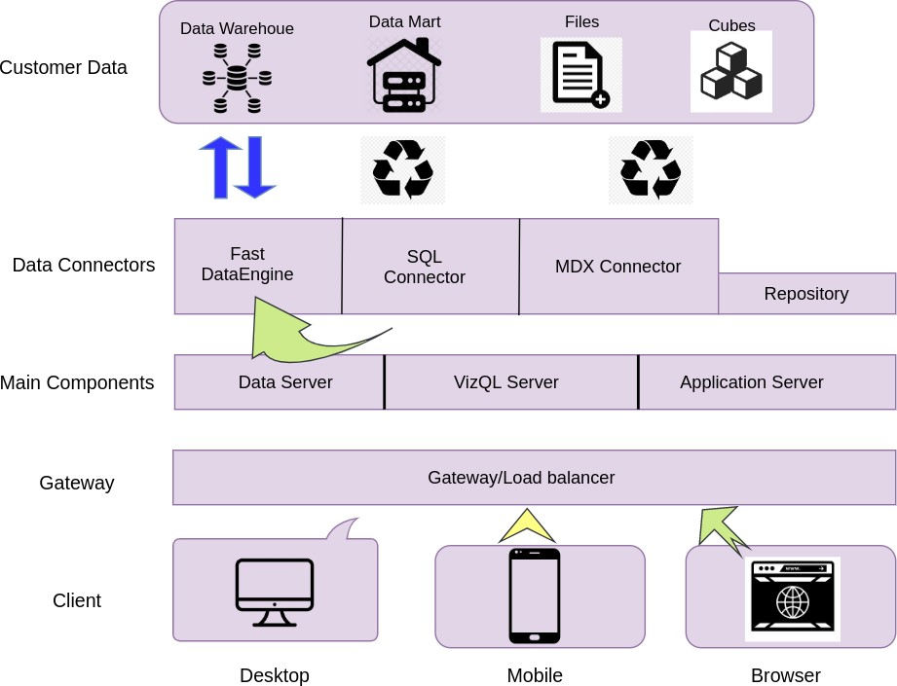

**Power BI Server Architecture**

Power BI Server, now known as Power BI Report Server, is an on-premises solution provided by Microsoft that allows organizations to host, manage, and distribute Power BI reports within their own network environment. The architecture of Power BI Report Server involves several components that work together to deliver Power BI reports to end-users.

The following diagram shows Power BI Server’s architecture:

### Shape Description automatically generated with low confidenceLOW LEVEL DESIGN

**6**

Power BI Server is internally managed by the multiple server processes.

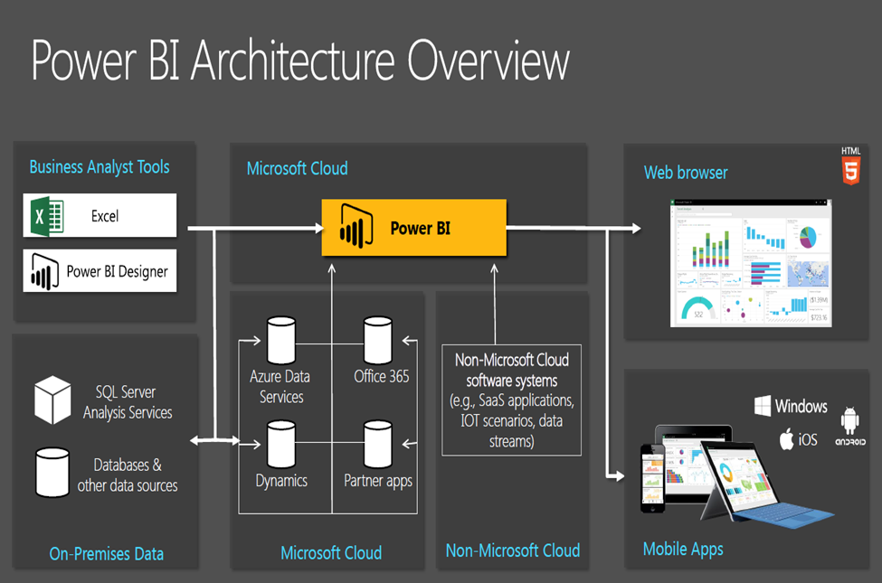

**1.Web Portal**:

The primary interface for end-users to access and interact with Power BI reports is through the web portal. Users can view, filter, and interact with reports using a web browser. The web portal provides a user-friendly interface for report navigation and exploration.

**2.Report Server:**

The heart of the Power BI Report Server architecture is the Report Server itself. This component manages report storage, processing, rendering, and distribution. It is responsible for handling user requests, retrieving data, rendering visualizations, and delivering the reports to users via the web portal.

**3.Report Builder:**

Power BI Report Server includes a client tool called Report Builder. This tool allows report authors to create and design Power BI reports using a desktop application. Once created, these reports can be published to the Report Server for distribution.

**4.Data Sources:**

Power BI reports hosted on the Report Server can connect to various data sources, including databases, Excel files, Analysis Services models, and more. Data sources are defined within the reports and are used to fetch the necessary data for visualizations.

**5.Data Models:**

Power BI reports can include data models that enable more complex analysis by combining and transforming data from different sources. These data models are typically created using Power Query and Power Pivot, and they help provide a performant experience by pre-aggregating and optimizing data.

**6.Security and Authentication:**

The Power BI Report Server supports different methods of authentication, including Windows Authentication and custom forms-based authentication. It integrates with existing organizational security systems to control user access to reports and data.

**7.Extensions:**

Power BI Report Server supports custom extensions, allowing developers to add custom functionality or integrate with other systems. These extensions can include custom data visualizations, data connectors, and more.

**8.Subscription and Alerts:**

Users can subscribe to reports and receive scheduled updates via email. Alerts can be set up to notify users when specific conditions are met within the data.

**9.Mobile Access:**

Power BI mobile apps can be used to access reports hosted on the Power BI Report Server. Users can view reports and dashboards on their mobile devices while connected to the organization's network.

1. **Architecture**

The architecture of the HR Analytics project serves as the foundational framework that orchestrates the entire process of extracting insights from the HR data. It encompasses various stages, each contributing to the seamless flow of data and analysis. This architecture is designed to enable efficient data handling, transformation, and deployment, ultimately leading to valuable HR insights.

1. **Architecture Description**

**3.1 Data Description**

In this stage, the HR data obtained in Excel format is thoroughly examined and understood. The data's structure, attributes, and characteristics are analyzed to gain insights into its potential significance for the project. This understanding forms the basis for subsequent stages of the architecture.

**3.2 Web Scraping**

Web scraping involves extracting pertinent data from online sources. If required, supplementary HR data can be collected through web scraping methods. This additional data can complement the existing dataset and enrich the analytical capabilities of the project.

**3.3 Data Transformation**

Data transformation is a pivotal phase where the raw HR data, whether from Excel or web scraping, is cleaned, structured, and formatted. This process ensures consistency, accuracy, and compatibility with subsequent analysis. Transformation may include handling missing values, standardizing formats, and encoding categorical variables.

**3.4 Data Insertion into Database**

Once the data is transformed, it's inserted into a database for efficient storage and retrieval. A well-structured database facilitates quick access to the data, enabling seamless querying and analysis. This phase establishes a solid foundation for performing complex analytical operations on the HR data.

**3.5 Export Data from Database**

Exporting data from the database is a critical step for generating insights and reports. The architecture allows for extracting specific subsets of data relevant to various analyses. This exported data serves as the input for generating HR metrics, trends, and visualizations.

**3.6 Deployment**

The deployment phase involves making the HR Analytics system accessible for users. This could entail setting up a web-based dashboard or interactive interface where stakeholders can interact with the analyzed HR data. The deployment process ensures that the insights derived from the data are easily accessible and actionable.

By following this architecture, the HR Analytics project leverages a systematic approach to handle HR data, transforming it into valuable insights that can inform strategic decisions and actions within the organization.

ShareSave

# Unit Test Cases

|  |  |
| --- | --- |
| **TEST CASE DESCRIPTION** | **EXPECTED RESULTS** |
| Rainfall parameter slicer | When clicked on the slicer, a dropdown should occur which has  various parameters of the rainfall. |
| House Price Parameter | When clicked on the slicer, a dropdown should occur which  describes the parameters of the House Prices. |
| Relation Between Rainfall and  Average Housing Price | Here a time series graph is shown of Rainfall VS Average House  Price data. |
| Rainfall and Average House Price  across the cities | Various city category is shown and a visualization is created  which shows the City Category and Avg. House Price and relation. |
| Relation between Rainfall and  Built-up Parameters across the Cities | The visual should show a bubble diagram of relation between various built-up parameters across various cities. |
| Min, Max & Avg. Housing Price Comparison by categories | This is an important visual in bar-graph which shows the category  of Max Housing Price, Mini Housing price and Avg. housing price across Built-up parameters and City categories. |